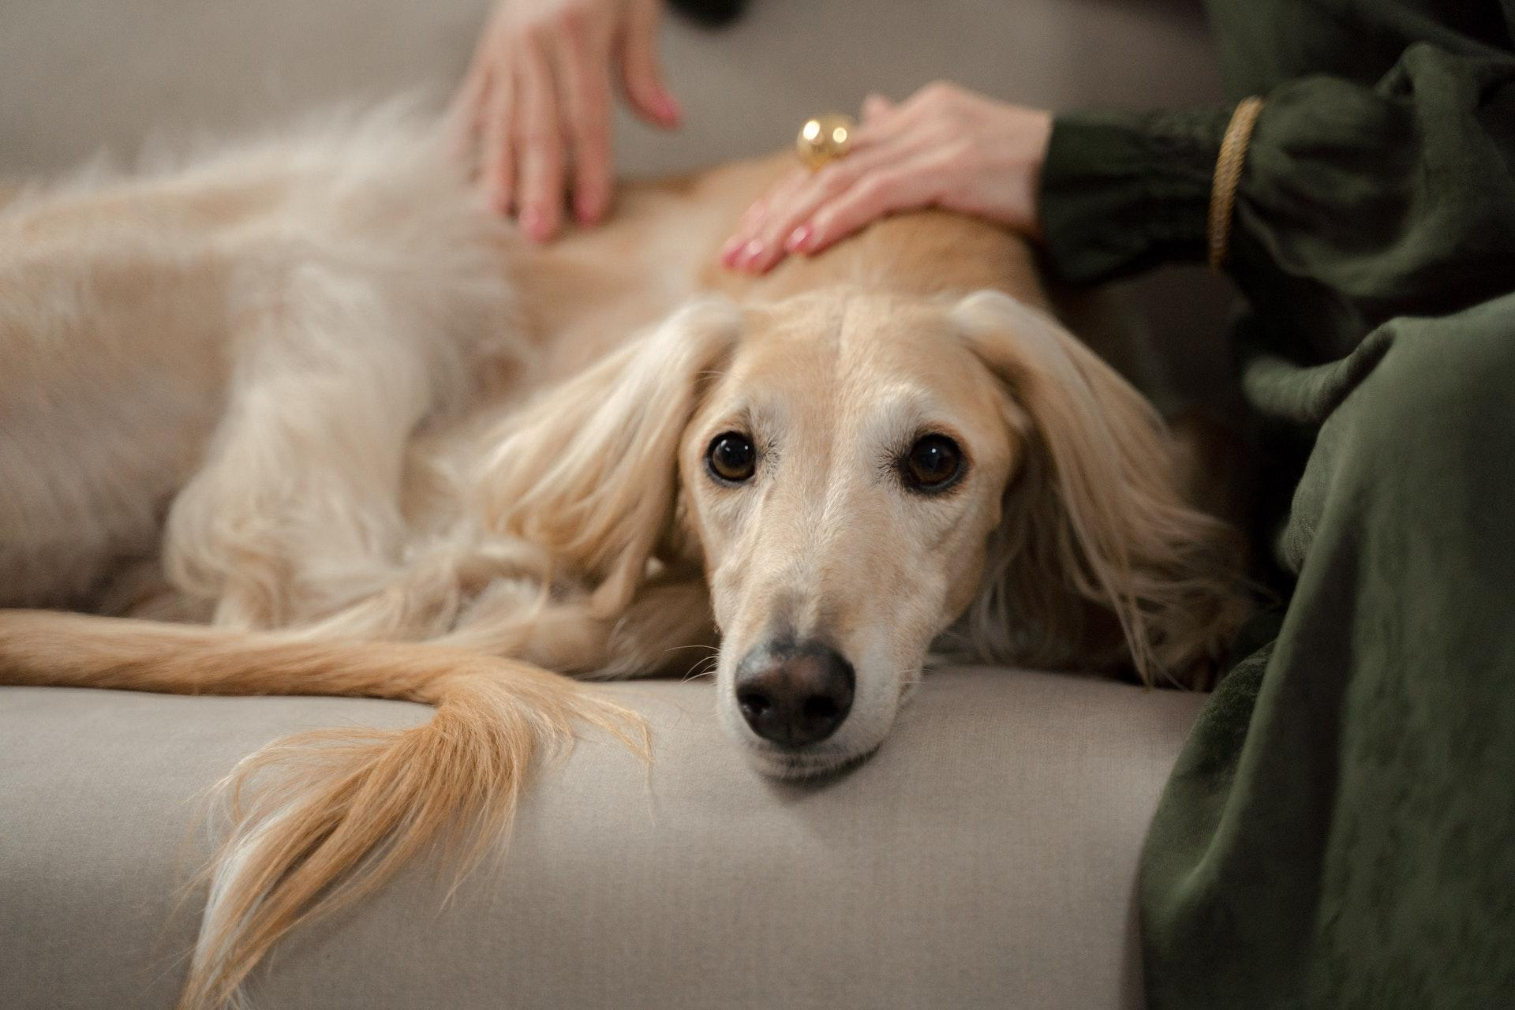

5 Ways to Keep Your Senior Pet Healthy and Happy

Over the years, your pet has become one of your most loyal friends. You’ve made so many wonderful memories together, and as they enter their golden years, you want to give them everything they need. Remember, it’s never too late for an older pet to learn new behaviors with training from Ultimate Companions! In addition to investing in age-appropriate training, here are a few things you can do to make sure your senior pet thrives.

Fence in Your Yard

Your pet might spend more time indoors as they get older, but you should double-check that the ID tags on their collar are readable in case they do get out. In order to keep them safe, you should also ensure that your yard is secure.

Purchase Pet Insurance

Pet insurance pays for veterinary care if your pet is injured or develops a serious illness. If you’ve noticed that your pet is slowing down, it’s a good idea to buy pet insurance well before they develop a chronic health problem. To find the right policy for your pet, Rover.com recommends considering what kinds of services you want coverage for and checking the fine print to make sure there are no unexpected exclusions.

Gentle Exercise

Your pet might not be as active as they once were - but they still need some exercise! To make sure your pet stays active without pushing them too hard, focus on incorporating gentle exercise into their schedule. You may want to spend some time in the yard with them each day or take them for short walks around the block.

In order to ensure that your pet has the energy for exercise, you can help them get a better night’s sleep with a cozy new bed. Furthermore, if your pet is having trouble moving around the house, you may want to set up small ramps to help them get up sets of stairs.

Dietary Changes

If you’re concerned about your pet’s digestive health, you’ll want to talk to your vet about gradually changing their diet. Sometimes, senior pets struggle to digest conventional pet food, and they may need food specifically developed for animals around their age. Transitioning your pet to a new food should be done over the course of a few weeks with their vet’s guidance.

Supplements

In addition to choosing specially formulated food, some senior pet owners give their pets supplements to help them stay healthy and ensure they get all of the nutrients they need. Dogs Naturally states that many older dogs benefit from supplements like prebiotics, probiotics, antioxidants, digestive enzymes, vitamin C, and omega-3 fatty acids. However, it’s always important to check in with your pet’s vet before giving them any supplements.

Caring for a senior pet can bring unique challenges. But although your pet’s needs may change, their love and loyalty to you will always be the same! With these tips, you’ll be able to give your pet the care they require no matter their age.

